Chapter 6 Functions
1. At least three benefits: (1) Reuse code; (2) Reduce complexity; (3) Easy to maintain.

2. See the Sections 6.2 and 6.3 on how to declare and invoke functions.

- Yes. return (num1 > num2) ? num1 : num2;

4. True: a call to a function with a void return type is always a statement itself.
False: a call to a function with a nonvoid return type is always a component of an expression.

5. int

6. A syntax error occurs if a return statement does not appear in a non-void function. You can have a return statement in a void function, which simply exits the function. But a return statement cannot return a value such as return x + y in a void function.

7. See Section 6.2.

- Computing a sales commission given the sales amount and the commission rate
double getCommission(double salesAmount, double commissionRate)

Printing a calendar for a month
void printCalendar(int month, int year)

Computing a square root
double sqrt(double value)

Testing whether a number is even and return true if it is
bool isEven(int value)

Printing a character for a specified number of times
void printChar(char ch, int times)

Computing the monthly payment, given the loan amount, number of years, and annual interest rate.
double monthlyPayment(double loan, int numberOfYears, double annualInterestRate)
Finding the corresponding uppercase letter given a lowercase letter.
char getUpperCase(char letter)

9. Line 6: function1 is not defined correctly. It does not have a return type or void.
Line 6: type int should be declared for parameter m.
Line 1: the function does not have a return statement.

10. Yes.

11. Line 1, String should be spelled string.
Line 3, why assigning 1 to n? does not make any sense.
Line 10, cannot pass 5 to string message.

12. Two functions with the same name, defined in the same program, is called function overloading. It is fine to have same function name, but different parameter types. You cannot overload functions based on return type.

13. These two functions have the same signature p(int).

14.
(a) double m(int x, double y)
(b) double m(int x, double y)
(c) double m(double x, double y)

15.The following are illegal.
void t1(int x, int y = 0, int z);
void t2(int x = 0, int y = 0, int z);

16 Inline functions are not called; rather, the compiler copies the function code in line at the point of each invocation. To specify an inline function, precede the function declaration with the inline keyword.

- Inline function is ideal for a short function body.

18
3.14159
314.159

19 j is a global variable. i is a local variable. Global variables are defaulted to 0 and local variables are not initialized. So i can have any value and j is 0.

20 j in line 4 is a global variable. i is a local variable. j inside the function p is a static local variable. The output is

i is 6
j is 6
i is 6
j is 7
global j is 40

21 Line 3: int i = 5 is wrong since n is already declared in the function signature.

22. "Pass by value" is to pass a copy of the value to the function.
"Pass by reference" is to pass the reference of the argument to the function.

(A) The output of the program is 0, because the variable max is not changed by invoking the function max.

(B) The output of the program is 2, because the address of variable max is passed to the maxValue function. 2 is assigned to variable max in the function.

(B)
Before the call, variable times is 3
n = 3
Welcome to C++!
n = 2
Welcome to C++!
n = 1
Welcome to C++!
After the call, variable times is 3

(C)
2
2 4
2 4 8
2 4 8 16
2 4 8 16 32
2 4 8 16 32 64

(D)
Same as in (C)

23. Change the function header to

void minMax(double a, double b, double& min, double& max)

24. This is a common programming error. Be careful. Don’t declare the parameters in the program because they are already declared in the function header.

max and min are already declared in the function header, and should not be redeclared in the function.

25.

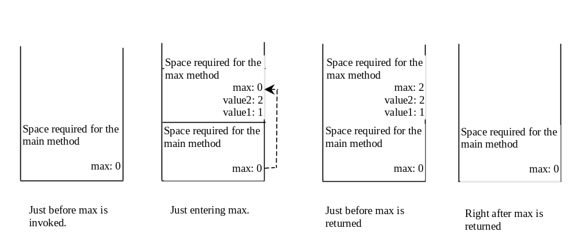
26.
x is 12
y is 10

27. When invoking p(k), the compiler cannot determine which function to call. It is ambiguous.

